
FURTHER MATHEMATICS
TRIAL EXAMINATION 2
SOLUTIONS
2006

_____________________________________________________________________

Section A – Core - solutions

Question 1

- 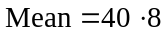
(1 mark)
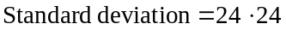(correct to two decimal places)
(1 mark)

- Looking at the scatterplot in Diagram 1, it appears that as travelling time increases, homework time decreases and therefore the sign of r; Pearson’s product-moment correlation coefficient, would be negative.
(2 marks)

- We are given that the coefficient of determination, 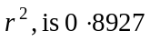. Therefore 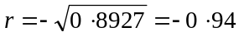 (correct to 2 decimal places). Remember that in part b. it was found that the sign of r was negative.
(1 mark)

- 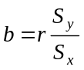
Now 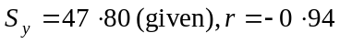 (from part c.) and 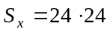 (from part a.). So 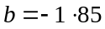 (correct to 2 decimal places)
(1 mark)
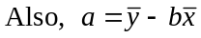
(from part a.)
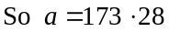
So the least squares regression line is given by
average daily
(1 mark)

Question 2

- The student with a travelling time of 30 minutes had a homework time of 78 minutes. The predicted value for a homework time when travelling time is 30, is given by
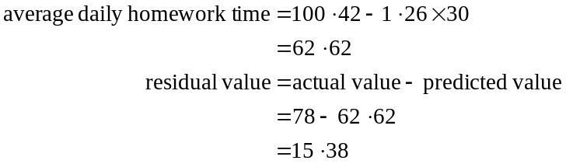
This point 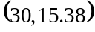 is shown on the residual plot below.

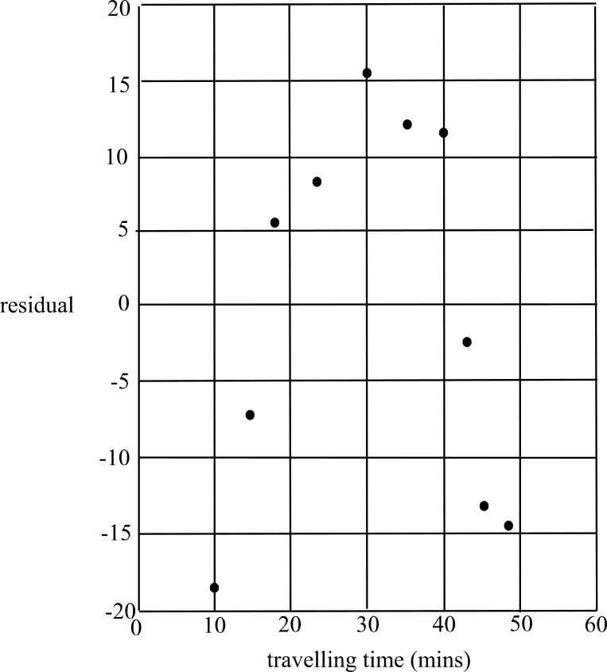

Diagram 3
(1 mark)

- The points plotted on the residual plot in Diagram 3 have a distinct pattern, which is like an inverted parabola. The points are not randomly placed either side of the x-axis. This tells us that a transformation is required to linearise the original data.
(1 mark)

- The missing entry is 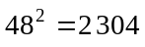.
(1 mark)

- Looking at the scatterplot of the original data in Diagram 2, we see that the data could be linearised by expanding the x-scale (which is the transformation tried) or by expanding the y-scale, thus a 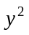 transformation could be tried.
(1 mark)

- Use a calculator to find the values.
where each value is expressed correct to 2 decimal places
(2 marks)

- i. A residual plot should be constructed.
(1 mark)

- A random collection of points spread approximately evenly on each side of the x-axis should be evident if the transformation has been successful.
(1 mark)
Total 15 marks

Section B

Module 1: Number patterns

Question 1

- 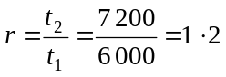
(1 mark)
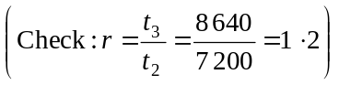
- Use a calculator to generate the sequence. During the 13th week of operation the number of calls made first exceeds 50 000.
(1 mark)
- 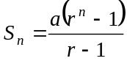
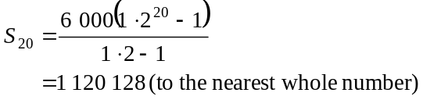
(1 mark)
- Since the sequence is geometric, each term is generated by multiplying the previous term by 1.2.
So, 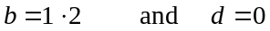
(1 mark) (1 mark)

Question 2
- 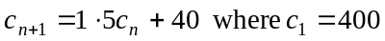
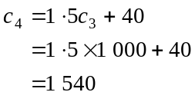
(1 mark)
- Since 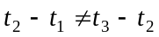,
i.e. 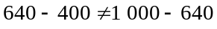,
the sequence cannot be arithmetic. (1 mark)
Since 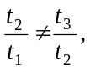
i.e. 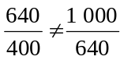,
the sequence cannot be geometric. (1 mark)
The sequence is neither arithmetic or geometric.
(1 mark)
- Use seq mode on your calculator to generate the sequence.
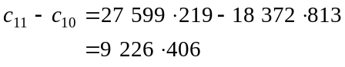
(1 mark) for obtaining either of 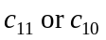 correctly
The difference in the number of calls made between weeks ten and eleven is 9 226 (to the nearest whole number).
(1 mark)

Question 3

- Method 1
Using seq mode on a calculator, generate the sequence.
Note that because this is a second order difference equation, you need to enter the initial values of the first two terms. Typically, this is done in the format 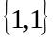.
The number of operators who would be working is 3.
(1 mark)

Method 2
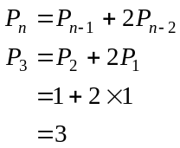
The number of operators who would be working is 3.
(1 mark)

- Use seq mode to generate the sequence (see part a. Method 1). (1 mark)
In the fifteenth week of its operation there would be 10 923 operators.
(1 mark)

- If there is capacity for only 1 500 operators, then they would need to stop recruiting during the 13th week since at the end of the 13th week the number of operators would rise to 2 731.
(1 mark)
Total 15 marks

Module 2: Geometry and trigonometry

Question 1

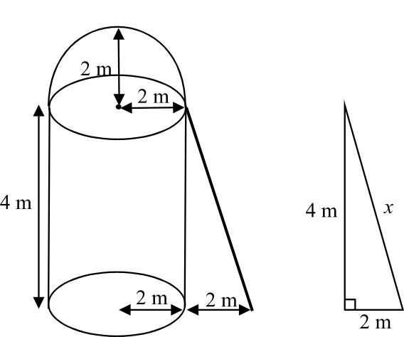

Let the length of the ladder be x.
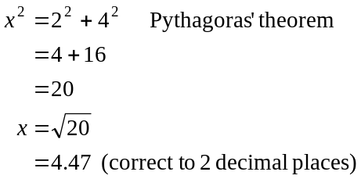
(1 mark)

b.
(1 mark)
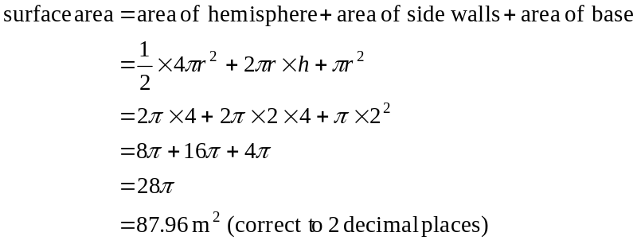
(1 mark)
c.
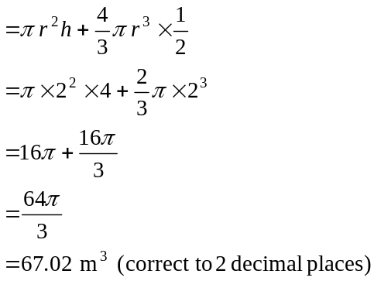
(1 mark)
Question 2
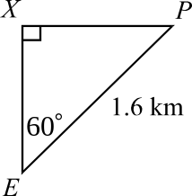
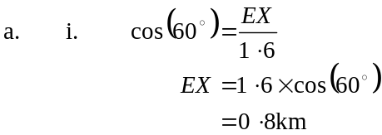
(1 mark)
- In 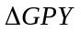,
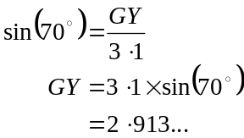
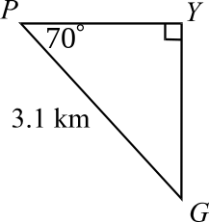
(1 mark)
So, using our answer to part i.,
the entrance gate at E is
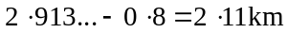 (correct
to 2 decimal places) north of G.
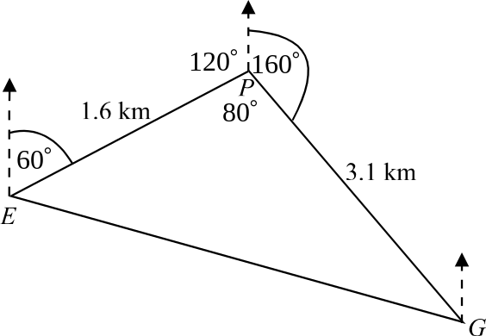
(1 mark)

b. i. Using the bearing angles given,
and using the facts that cointerior
angles add to give 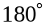; that is
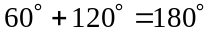, and angles
around a point add to give 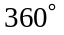
we see from the diagram that
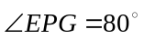.
(1 mark)

- In 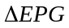 we have two sidelengths and an included angle so use the formula 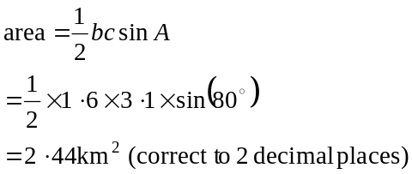
(1 mark)
c. In ,
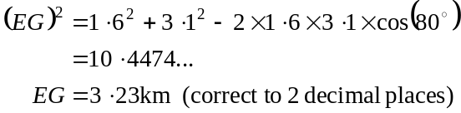
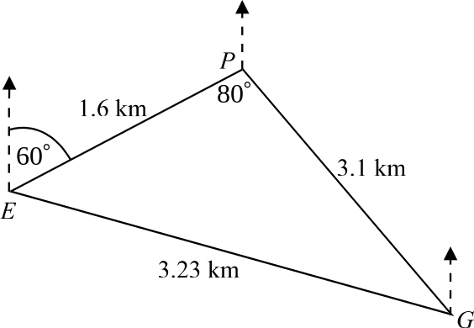
(1 mark)
d. In , using the sine rule, we have
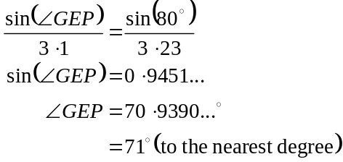
(1 mark)
So the bearing of the exit gate at G from
the entrance gate at E is 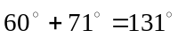.
(1 mark)

Question 3

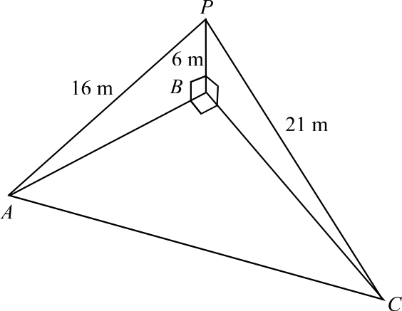

In 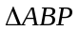
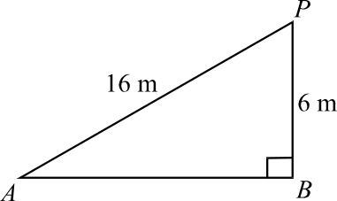

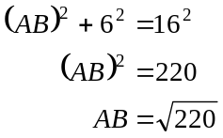
(1 mark)

In 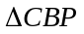
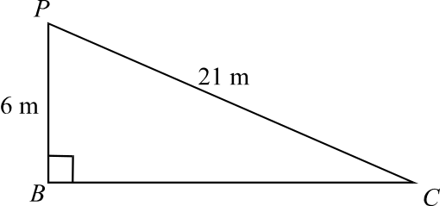

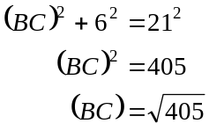
(1 mark)

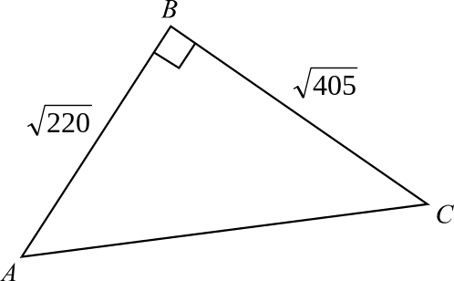
In 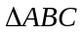
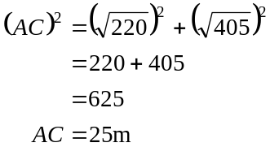

(1 mark)
Total 15 marks

Module 3: Graphs and relations.

Question 1

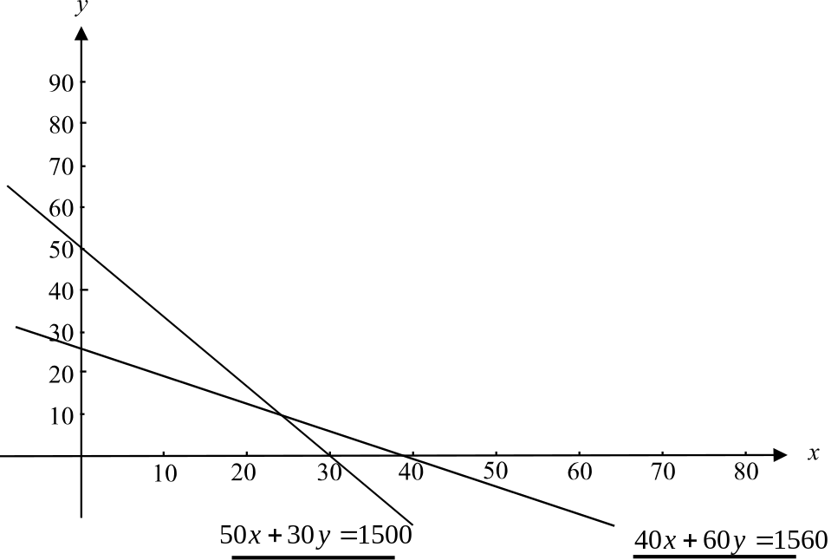

(1 mark)

- To find the x-intercept of the line with equation 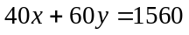 let 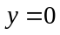.
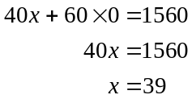
(1 mark)

- Method 1
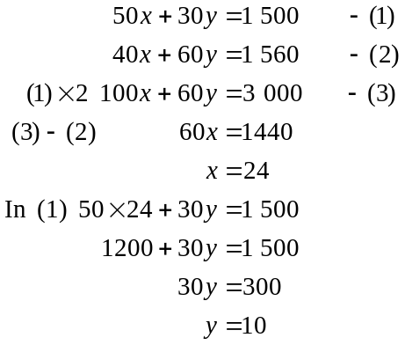
(1 mark)
Point of intersection is 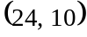.
(1 mark)

Method 2 – Using a graphics calculator
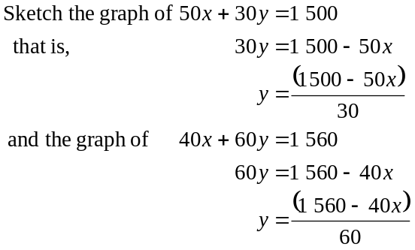
The point of intersection is .
(2 marks)

- Café Arnold: 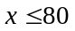
Café Arnie: 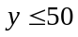
(1 mark)

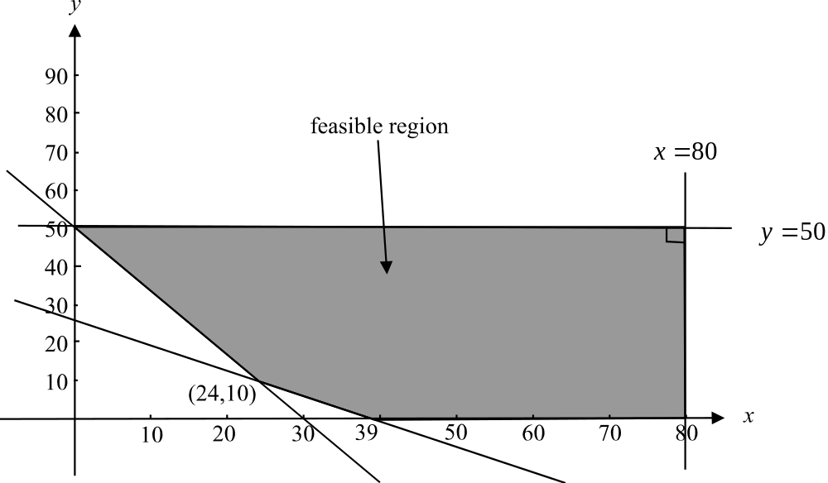

(1 mark) correct vertical border
(1 mark) correct horizontal border
(1 mark) correct shading

- 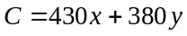
(1 mark)
g. Check each of the corner points of the feasible region in the formula .
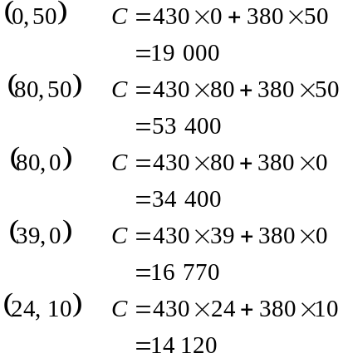
The minimum cost is $14 120.
(1 mark) correctly substituting a
couple of points into the cost function
(1 mark) obtaining the correct answer

Question 2

- Arnold is stationary when the graph is horizontal; that is, when the gradient or slope of the graph is zero. This occurs between 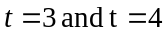. So Arnold was stationary for approximately 1 minute.
(1 mark)

- Arnold was riding fastest when the gradient of the graph was the steepest. This occurs at approximately 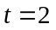.
(1 mark)

- At 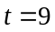, Arnold is 3.5km from Café Arnold; that is 1.5km from Café Arnie.
(1 mark)

- Average rate of change between 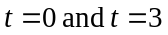 is given by 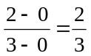 km/min.
Note that at 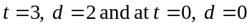.
(1 mark)
Total 15 marks

Module 4: Business-related mathematics

Question 1

- To discover the GST in a price, divide by 11.
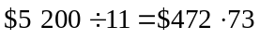.
The price of the television before GST was applied was 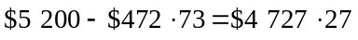.
(1 mark)

- i. Ray pays 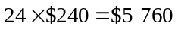.
(1 mark)

  - 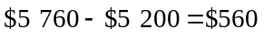 is paid in interest.
(1 mark)

- i. Annual rate of interest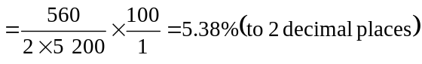.
(1 mark)
(This represents the flat rate of interest.)

- 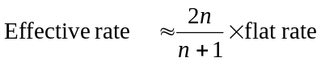
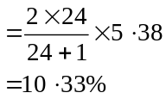
(1 mark)

Question 2

- 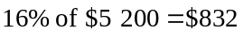. This is the amount that the TV will be depreciated by each year.
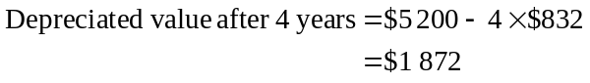
(1 mark)

- Depreciated value after 4 years
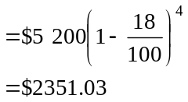
(1 mark)
(1 mark)

Question 3

- Use TVM solver to solve this.
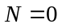 (place cursor at the N value)
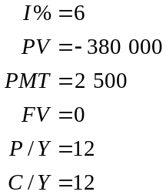
(- ve because this goes to the bank)
(+ve because this goes to Ray)
PMT : END BEGIN
The answer is 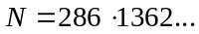 (1 mark)
This means that Ray’s annuity will last for 286.1362 months, which is 23.8 years.
(1 mark)
- Use TVM solver to solve this.

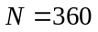
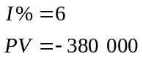
(- ve because this goes to the bank)

PMT = 0 (place cursor at the PMT value)
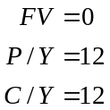
PMT : END BEGIN
The answer is 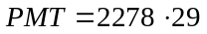. Ray would receive a monthly payment of $2 278.29.
(2 marks)
- With a perpetuity, Ray is effectively living off the interest of his investment and his principle remains intact. If P is the amount invested at an interest rate of r% per annum and a regular payment of Q is paid then 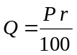. This formula is obtained by letting A = P in the annuities formula since for a perpetuity, the principle is equal to the value of the annuity.
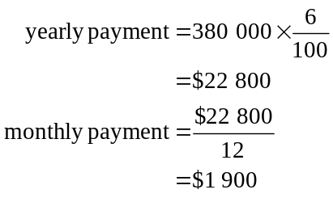
(1 mark)
- Ray would need a yearly payment of $30 000.
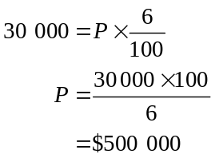
(1 mark)
e. The major advantage that a perpetuity has is that the principal always remains intact whereas with an annuity, eventually the principal will reduce to zero.
(1 mark)

Total 15 marks
Module 5: Networks and decision mathematics

Question 1

- By inspection, the shortest path is along OADF with a length 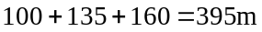.
(1 mark)

- Some of the Hamiltonian circuits that are possible are
OBEFDCAO OCDFEBAO
OBDEFCAO OCFDEBAO
OBEFCDAO
OABEFDCO
OABDEFCO
OACDFEBO
OACFDEBO
(1 mark)
Note that a Hamiltonian circuit is where each vertex is visited just once and the circuit starts and ends at O.

- i For an Euler circuit (each edge is travelled along just once) to exist, the degree of each vertex must be even.
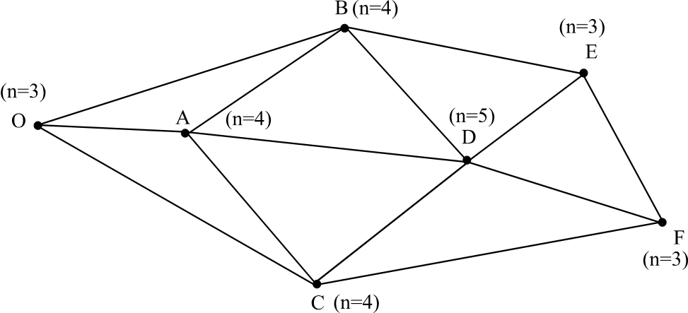

On the network above, the degree of each vertex is shown.
Since vertices, O, D, E and F have odd degrees an Euler circuit cannot exist.
(1 mark)

  - Some possible roads that could be added would run from O to E and D to F or from O to F and D to E.
(1 mark)

Question 2

 | A | B | C | D
M | 900 | 800 | 700 | 600
N | 750 | 550 | 850 | 850
O | 950 | 800 | 800 | 650
P | 900 | 900 | 850 | 900

Step 1
300 | 200 | 100 | 0
200 | 0 | 300 | 300
300 | 150 | 150 | 0
50 | 50 | 0 | 50

Subtract the minimum value in each row
from each of the other values in the row.

Step 2
300 | 200 | 100 | 0
200 | 0 | 300 | 300
300 | 150 | 150 | 0
50 | 50 | 0 | 50

Draw the minimum number of lines (horizontal
or vertical) through the values so that
each zero is covered.

(1 mark)
There are less than 4 lines so we don’t have an optimal allocation.

Step 3
300 | 200 | 100 | 100
300 | 100 | 400 | 400
300 | 150 | 150 | 100
150 | 150 | 100 | 150

Add the minimum ‘uncovered’ value
i.e. 100 to each of ‘covered’ values.

Repeat Step 1
200 | 100 | 0 | 0
200 | 0 | 300 | 300
200 | 50 | 50 | 0
50 | 50 | 0 | 50

Repeat Step 2
200 | 100 | 0 | 0
200 | 0 | 300 | 300
200 | 50 | 50 | 0
50 | 50 | 0 | 50

200 | 150 | 50 | 50
200 | 50 | 350 | 350
200 | 100 | 100 | 50
50 | 100 | 50 | 100

Repeat Step 3

(1 mark)
Repeat Step 1and Step2
150 | 100 | 0 | 0
150 | 0 | 300 | 300
150 | 50 | 50 | 0
0 | 50 | 0 | 50

The bipartite graph shows the possible allocations.
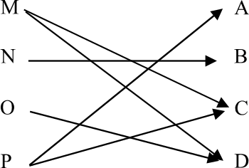

M maintains C
N maintains B
O maintains D
P maintains A
(1 mark)

- The annual cost for these allocations is .
(1 mark)

Question 3

- The boxes at the start of each activity (edge) show the earliest start time (left hand box) and the latest start time (right hand box).
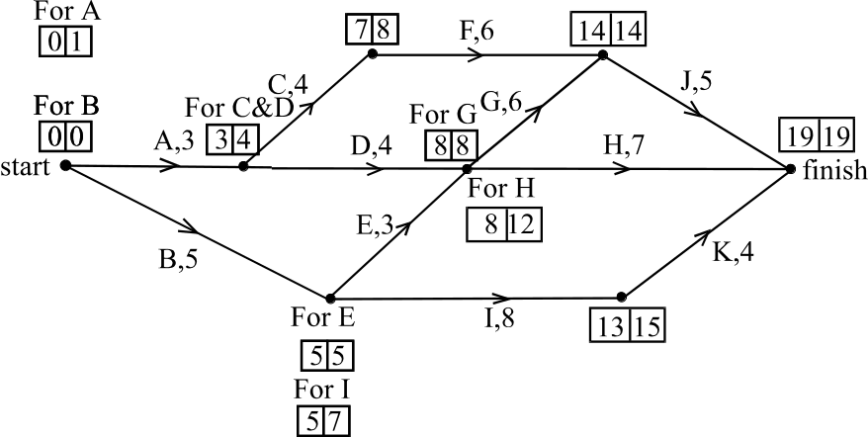

The earliest start time for H is 8 weeks. (1 mark)
The latest start time for A is 1 week.
(1 mark)

- The critical path for the project is B, E, G, J.
The minimum time needed to complete the project is 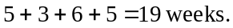
(1 mark)

- The float or slack time for an activity is equal to the latest starting time – earliest starting time. This is greatest for activity H where the difference is 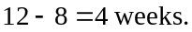
(1 mark)

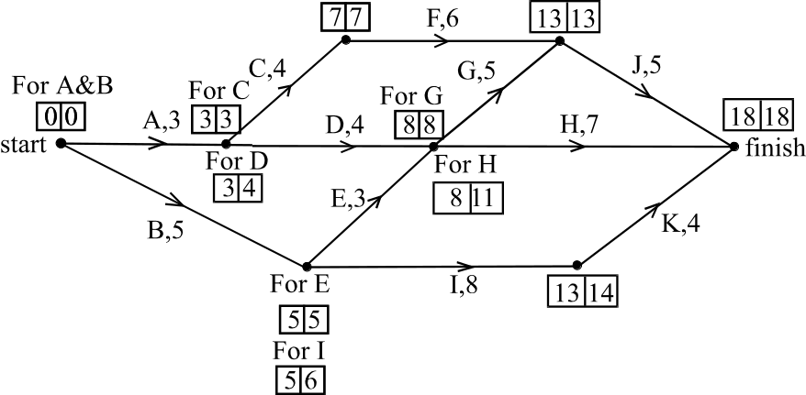
- i.

(1 mark)
Those activities that now cannot be delayed are A, C, F, J, B, E and G.
(1 mark)

- It is not cost effective to reduce activity G to 4 weeks because other activities that don’t lie on the critical path that G lies on, for example A, C, F and J, will still take a total of 18 weeks to complete.
(1 mark)

Total 15 marks

Module 6: Matrices

Question 1

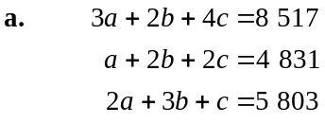
(1 mark)

b. 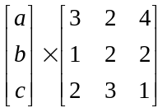
The number of columns of the first matrix is 1. The number of rows of the second matrix is 3. The two matrices can therefore not be multiplied.
(1 mark)

- Enter the matrix into a calculator. The determinant and inverse can be calculated.

  - its determinant is –10.
(1 mark)

  - its inverse is 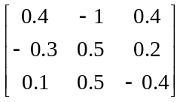
(1 mark)

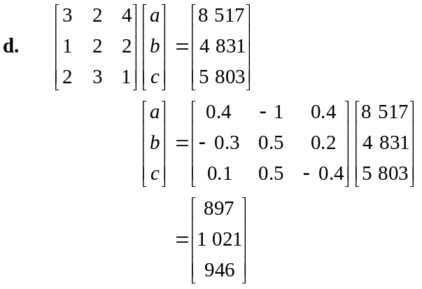
(1 mark)
So, in December 2005, 897 books were borrowed from Alphinghurst library, 1021 books were borrowed from Broadlake library and 946 books were borrowed from Casaville library.
(1 mark) for the interpretation of the solution matrix

Question 2

- 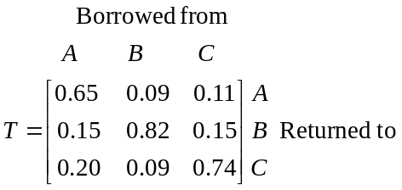
(2 marks)

- 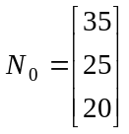
(1 mark)

- The matrix 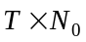 tells us how many of the large print books will be located at each of the libraries one month after they are made available for loan.
Use a calculator for the calculation.
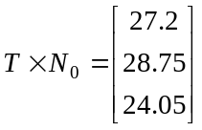
(1 mark)
There would be 27 books located at Alphinghurst.
There would be 29 books located at Broadlake.
There would be 24 books located at Casaville.
(1 mark)

- We want to find the number of large print books in the respective libraries after 12 months.
Now, if 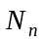 represents the number of large print books in the respective libraries n months after they are made available for loan, then
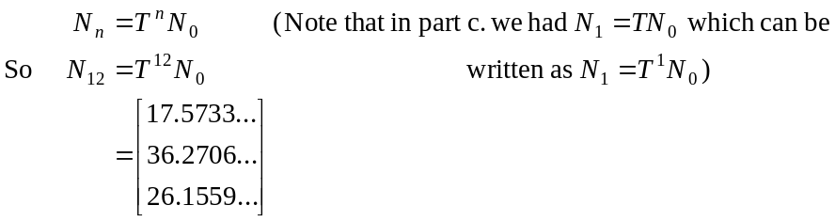
Rounding off, at the start of 2007,
there are 18 books located at Alphinghurst
there are 36 books located at Broadlake
there are 26 books located at Casaville
(1 mark)

- We need to find the steady state matrix N where
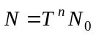
as n becomes large.
From part d. we have seen that
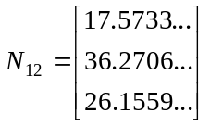
Let’s try 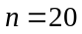,
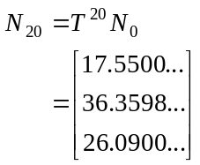
(1 mark)
Let’s try 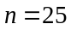,
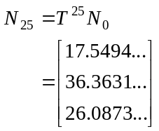
Let’s try 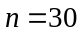,
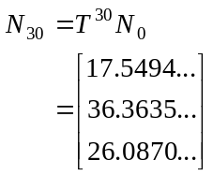
The values have barely changed out to the fourth decimal place so it appears that a steady state solution has been reached.
Rounding off to the nearest whole number, we have over the long term,
  - 18 books located at Alphinghurst
  - 36 books located at Broadlake
  - 26 books located at Casaville.
(1 mark)
There were 35 of the large print books originally allocated to Alphinghurst. When the steady state is reached that number had dropped to 18. So yes, the librarian is correct, the number of books located at Alphinghurst will be only about half of those originally allocated.
(1 mark)
Total 15 marks

